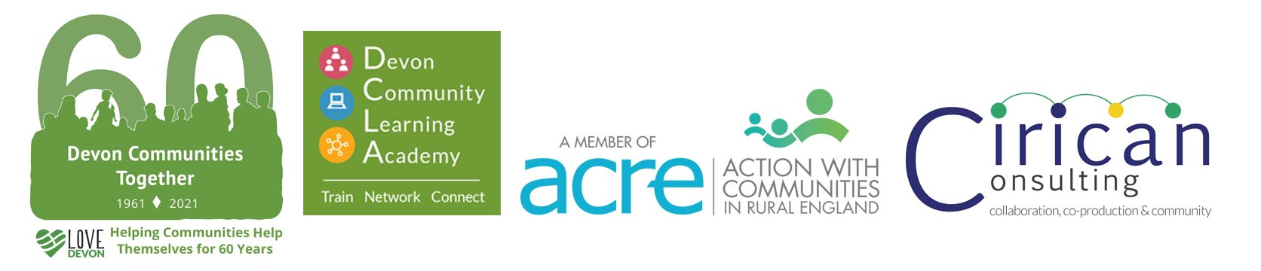



**COVID -19 Local Outbreak Management Plan**

**Large Grants Scheme**

**Urgent Call for Funding Proposals**

Devon Communities Together (DCT) along with the Public Health Team are seeking project proposals for the 2021 Contain Outbreak Management Fund (COMF) that support Covid-19 outbreak management to suppress the virus, increase engagement with control measures, including mitigating the impacts of lockdown on our communities and increasing resilience for those at risk and in isolation.

We have £145 000 in the Contain Outbreak Management Fund, and we are asking Devon based non-profit organisations and partners to consider identified needs that have arisen as a result of the pandemic and apply for Contain Outbreak Management Funding to address and mitigate these impacts over the Autumn/Winter months. **The funding must be spent by recipients by the end of March 2022.**

There a minimum of £10 000 and a maximum limit of £25 000 funding, proposals must not provide funding for core statutory services and must be aligned to the following COMF criteria:

1. Enhanced communication and marketing e.g. towards hard-to-reach groups and other localised messaging.
2. **Targeted interventions for specific sections of the local community and workplaces**.
3. Harnessing capacity within local sectors (voluntary, academic, commercial).
4. Extension/introduction of specialist support (behavioural science, bespoke comms).
5. **Community-based support for those disproportionately impacted such as the BAME population**.
6. Support for engagement and analysis of regional areas to assess and learn from local initiatives.
7. Providing support, as needed, to vulnerable people classed as Clinically Extremely Vulnerable
8. **Support for rough sleepers**

**At this phase of the Pandemic, we particularly welcome proposals that meet the criteria in bold.**

**We would also welcome proposals supporting those disproportionately impacted by Covid or those not able to access programmes and support to ensure we are impacting on health inequalities.**

**Covid-19 impact in Devon**

While the COMF enables us to support projects noted in the criteria above, we want to ensure that the fund is targeted to support areas and populations most impacted by Covid-19 in Devon as outlined in the Director of Public Health’s Annual Report.

[Devon County Council Public Health Annual Report 2020 - 21 (kinstacdn.com)](https://mk0devonhealthad1tlc.kinstacdn.com/wp-content/uploads/DCC-Public-Health-Annual-Report-2021-Accessible-Version.pdf) p30

For example:

* **Employment.** The impact of seasonal work should also be considered.
* **Debt and Financial Precarity.** The number of people claiming Universal Credit has dramatically increased.
* **Housing** is an issue for privately renting tenants who face unemployment and/or benefit delays.
* **Rough Sleepers** are more likely to have underlying health conditions and face difficulties in following Public Health advice
* **Education** and the impact of outbreaks and missed attendance
* **Domestic Abuse** levels have increased
* **Child Safeguarding** referrals have increased and the complexity of issues has increased
* **Young children and families –** child development delay has increased, especially social and emotional and speech and language development. Children impacted by parental need.
* **Mental Health**
* **Loneliness and isolation**
* **Bereavement**
* **Physical health**
* **Digital Exclusion**

**Types of groups we are aiming for**

Community, Voluntary Sector, Social Enterprises with Social Purpose, Support for BAME and Children

and Young people, Housing proposals. Only not for profit organisations are eligible.

**Timescales**

* Provision of funding November 2021
* Spend required by end March 2022

**Proposal deadline: Rolling basis until funding is distributed. Please submit bids as soon as possible to enable funding to be spent by 31 March 2022.**

**Who can apply?**

* Any statutory, voluntary, community or academic organisation
* Collaborative applications are welcome from organisations partnering to maximise impact and system expertise but the collaboration will require a lead partner.
* Applications are welcome from organisations who have already received other funding from Devon County Council.

**Terms of Funding**

Successful applicants will be required to enter into a formal grant agreement with Devon Communities Together which will specify the terms and conditions of the funding, the required outputs, the timescales and reporting requirement. This will include providing monthly progress reports, case studies and evidence of expenditure. Devon Communities will reserve the right to if these terms are not met.

Payment will usually be in arrears and details of spend will be required to be kept for 6 years.

**What funding can be used for:**

Directly attributable costs relating to the above criteria a) to h)

Reimbursement of costs incurred prior to the project start date will be at the discretion of Devon Communities Together.

**What cannot be funded?**

Delivery of NHS services or core statutory services.

The following are not eligible costs for COMF purposes. This list is not exhaustive.

* costs of democracy
* promotion of political or religious activity
* interest payments
* annual costs (e.g. licences) where the supply continues after the 31st March 2022
* redundancy costs
* non-attributable operating overheads etc
* any ongoing liabilities resulting from the project activity
* any items which you have already had EU or other public funding for
* recoverable VAT

**Our Decision Process**

A panel will be established to consider if applications meet the above criteria. The panel will consist of DCT, DCC and other VCSE organisations.

We will also endeavour to ensure a geographical spread of projects across Devon and that priority areas of need are meet.

**Payment of grant funding**

Payment terms will be agreed based on individual projects. As a standard this would be on achievement of the agreed project outcomes/outputs.

Any costs incurred prior to the agreement of a grant, are at the risk of your organisation.

**You won’t automatically get a grant**

When you apply for a grant, you’re competing with other applicants in the eligible area. We’re looking for projects that best meet the priorities for funding, and that are good value for taxpayers’ money. If you can show this clearly in your application, you’re more likely to get a grant.

Contain Outbreak Management Fund (COMF) is limited and will be prioritised to applications that contribute the most to the COMF’s criteria, as set out in the Introduction.

Devon Communities Together reserves the right not to make any awards if it is considered that the proposals are not aligned with the COMF criteria or they are not showing good value for money.

**Funding proposal form**

The funding proposal form is your opportunity to describe how your project will meet the above criteria identify the aims and anticipated impact of the project, describe how you will ensure the project is delivered and will be able to meet the delivery date of March 2021 and describe the learning and evaluation process you will apply.

**If you would like this information in another format, please contact the COMF team on** [**info@devoncommunities.org.uk**](mailto:info@devoncommunities.org.uk)**.**