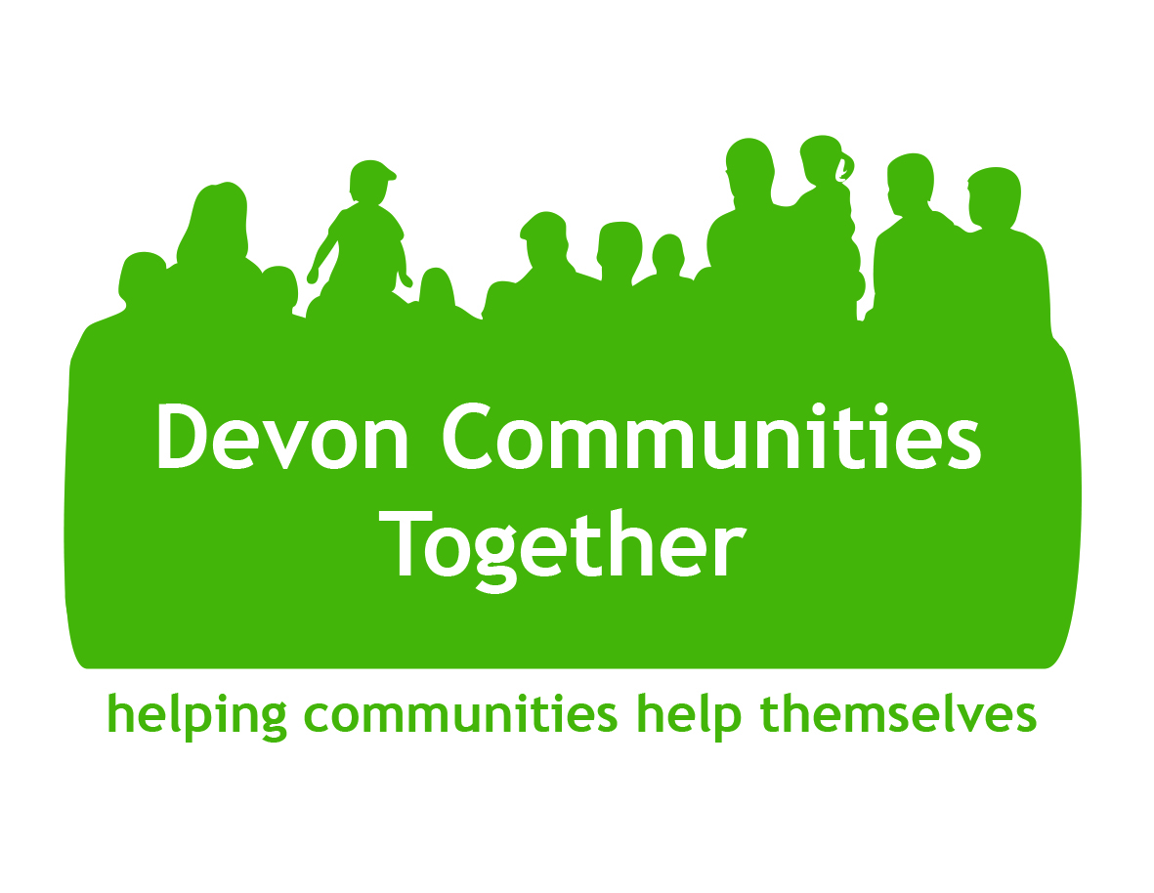

January 2022

Dear Applicant

Support Services (HR) Officer

Term: Permanent appointment
Salary: £19,868 fte (actual salary £9,934)
Hours: 0.5 fte (18 hours 8 minutes per week)
Place of Work: Office (currently Exeter) and from home, to be decided

Thank you for your interest in the above post. Please find attached:
- Job description and person specification
- Information about the Immigration, Asylum and Nationality Act 2006
- Application Form

Devon Communities Together (DCT) is the operating name of The Community Council of Devon. We are an independent charitable company founded in 1961, and part of a national network of Rural Community Councils.

We are a community development organisation. We ‘help communities help themselves’ by providing advice and information and supporting projects throughout Devon. We have a special concern for Devon’s rural communities and especially those who are at risk of isolation and disadvantage and for whom rurality brings an additional challenge to their daily lives.

Our vision is of dynamic communities shaping their own futures. Our Mission is to inspire and support communities to be thriving, resilient and inclusive.

Please use the Application Form provided; we do not accept Curriculum Vitae (CV). However, should you think it would be helpful to submit a Magna Vitae as part of your application, we would be pleased to accept this (please see below for details).

Please note that the shortlisting process involves scoring applicants against how well they match the person specification, so please provide clear evidence of how you meet each of the requirements. Where job requirements and operational demands allow, we will consider any reasonable requests for flexible working patterns.

Our preferred method of receipt of applications is via e-mail to recruitment@devoncommunities.org.uk . However, if you prefer to send a hard copy of your application in the post please mark the envelope ‘Confidential: Job application’ and provide a stamped addressed envelope if you require acknowledgement of its receipt.

Deadline for applications: Please note that all applications must be received at Devon Communities Together office by 9am on Tuesday 8th February.
If you require this application pack in large print or a different format please contact Devon Communities Together on 01392 248919
Interview Date: Interviews will take place (probably via Zoom or similar) on Tuesday 15 & Wednesday 16th February. The start date will be as soon as practicable after interview.

It is Devon Communities Together’s practice to only contact those applicants selected for interview, so if you have not heard from us by Friday 11th February, please assume your application has been unsuccessful.

Magna Vitae
Should you wish to submit a Magna Vitae as part of your application, we would be pleased to accept this. A Magna Vitae is an honest description of a candidate’s past to celebrate how they have overcome the difficulties in their life. It gives an explanation of what they have learned during their journey and describes the events during different periods of the person’s life. The Magna Vitae is always simple, clear and direct.

It includes:
- a photo of the candidate
- a list of their achievements, skills and attributes
- their preferences, for example: working as part of a team, working night shifts etc.
- references, often from a professional involved in the support of the individual
- their ability to travel
- contact information

for more information on Magna Vitae please visit
https://www.learndevon.co.uk/magna-vitae-an-honest-cv

