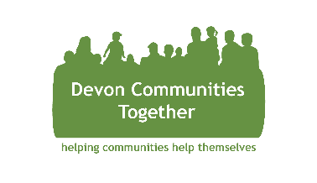**Devon Communities Together**

**Could you be our new Trustee?**

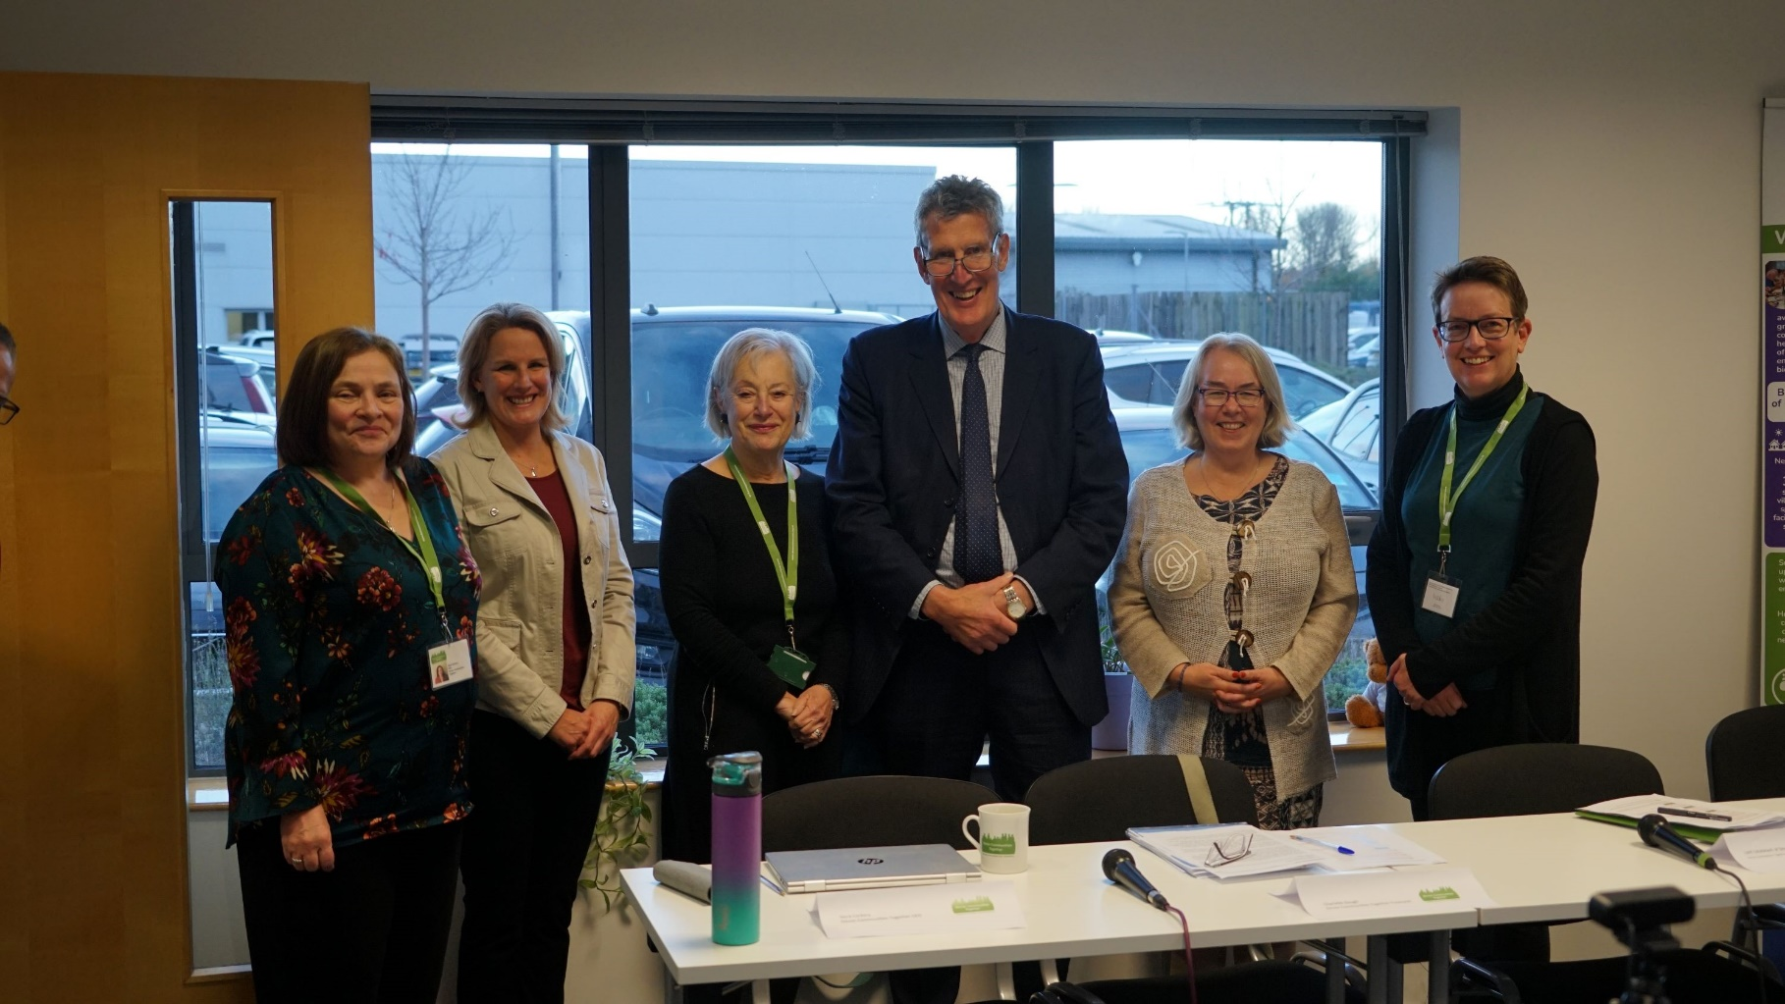

**96% trustees said they learned a new skill\***

**73% trustees said it boosted their confidence\***

**84% trustees said it made them happier\***

**Our trustees generated £48.46k in social value in the last year!**

*Pictured l-r: Nora Corkery, CEO; Charlotte Gough, Treasurer; Renee Smithens, Vice Chair; HM Lord Lieutenant David Fursdon, President; Nicola Gurr, Chair.*

**Could you help us support communities in Devon to thrive?** Devon Communities Together is recruiting for **two** new Trustees to join our dynamic and Board of Trustees. With a new UK government in place, and the pending restructure of our council networks across the county, this is your opportunity to help shape the future direction of our charity and ensure that the voices of Devon’s rural and coastal communities are heard loud and clear. **Being a Trustee of a charity is a great way of using your experience and enthusiasm to make a difference to people’s lives, meet new people and even learn some new skills along the way.**

***Who are we?***

DCT is an independent charity and company limited by guarantee. We are one of 37 Rural Community Councils and a member of Action With Communities in Rural England (ACRE), a national network of all the Rural Community Councils in shire counties across England. We have been supporting rural and coastal communities across Devon for over 60 years and we are a well-established and respected member of the voluntary and community sector in Devon and a member of the Torbay, Plymouth & Devon Voluntary, Community and Social Enterprise sector Assembly.

***What do we do?***

Living in Devon can be wonderful but we understand that there are also many communities and people that are currently facing serious challenges. Devon Communities Together is an Asset Based Community Development organisation, working alongside a diverse range of people, community groups and statutory service partners to deliver place based support to communities all over Devon. Our vision is to inspire and support rural and coastal communities across Devon to be dynamic and sustainable places for people to live and work. We work together to achieve this vision through a wide range of innovative projects and impactful services that help communities and individuals to find solutions to the challenges they are facing.

We support rural and coastal communities across Devon around issues such as older people at risk of loneliness and social isolation; young people struggling to access employment and housing; those in food or fuel poverty; social enterprises and small businesses; groups keeping their communities safe during emergencies; village hall committees maintaining these vital community assets – and many more.

Our approach is always to ‘help communities to help themselves’.

***What does our Board of Trustees do?***

Our Board members have a dual legal role as Trustees of the Charity and Company Directors. The Board takes a strategic overview of the organisation and provides guidance to our Executive Management staff team, on the financial and legal aspects of organisational management. As our new Trustee, you will play a key strategic role in shaping the future direction and sustainability of our charity.

***Trustee Requirements***

The expected time commitment is approximately up to one day a month, attending various meetings and events on behalf of the charity and representing the organisation within your personal and professional networks. Trustees meet on a quarterly basis for an in person Board meeting, and may be asked to join a sub-committee which work on the same quarterly basis. The board of Trustees also are invited to attend an all day in person away day annually, as well as the AGM.

***Trusteeship Benefits***

You will benefit from the opportunity to impart your knowledge and expertise, develop valuable new skills, as well as meet and network with new colleagues, including our expert staff team. We provide opportunities for Trustees to join staff outings, public events, working groups and team meetings and training events if they wish to, and we provide regular trustee communications so that you feel part of our team. Above all, you will be providing valuable guidance to help DCT support communities all over Devon, helping us create positive change for thousands of people.

***What skills and experience are we looking for?***

Are you passionate about using your skills and experience to help shape the future of our charity? Whether you are an experienced Trustee, or wanting to take your first step at Board level, we would love to hear from you:

* Perhaps you are looking for a new voluntary challenge. This opportunity could give you the chance to impart your experience and knowledge within our organisation.
* With the exciting, and in some cases rapid, developments of digital technology, we would welcome the expertise of someone in this industry to ensure that we are ready to support our communities in Devon embrace these changes and provide support where it is needed.
* Devon has a wealth of experienced people in the farming and land management sector, so we would welcome expressions of interest from landowners, individuals who work for land management companies or members of the farming or agriculture community. These vital skills will enable us to continue to ensure that we are supporting the rural and coastal communities across the county.

*\*Source: https://www.gettingonboard.org/post/how-to-recruit-trustees-for-your-charity-a-practical-guide-launches-today*