Devon Emergency Resilience Fund
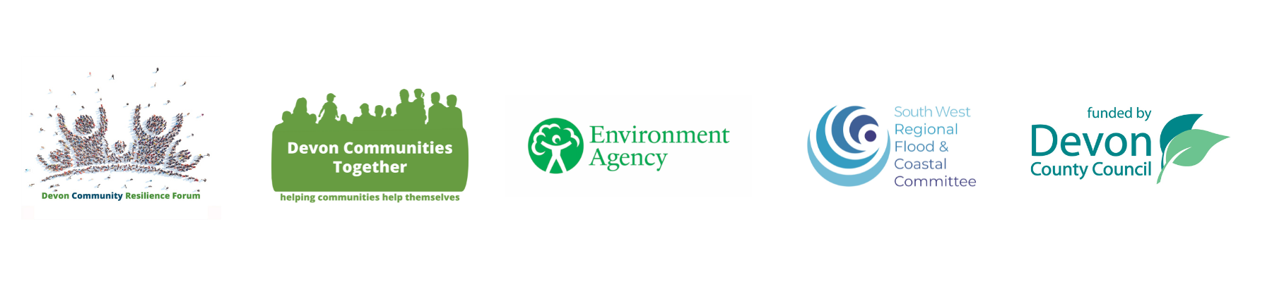
Application Form for Scheme 1 and Scheme 2

About the Group

Name

Address

Post Code

District / Local Authority
Which scheme are you applying for?
Scheme 1: We are working towards creating a: *Community Emergency Plan / Flood Plan (*delete as appropriate) |  | Estimated completion date:
Scheme 2: We have a *Community Emergency Plan / Flood Plan (*delete as appropriate) |  | Date of Plan:

Complete your bank details to enable a bank transfer (this must be for an organisation):

Bank Acct Name:
Bank Acct Number: |  | Bank sort code:

About you (Main Contact)

First name |  | Surname
Your role
Telephone |  | Mobile

Email

Address

Post Code

What you are applying for?

What will this funding be used for?

Why is this needed?

What risks will the grant help mitigate against?

What is the total cost?
How much are you applying for? (maximum Scheme 1 - £250 Scheme 2- £1,500)
Where will any balance come from?

Budget Breakdown

Expenditure Item | £
Total Cost

Please make sure all estimates / quotes are included with your application.

Please attach a copy of your latest Community Emergency Plan / Flood Plan or draft plan with your application, if you have one, as well as quotes or screenshots for the items you wish to purchase.

I confirm that I have read and understood the guidelines

Signature: | (can be electronic)
Name:
Position:

Please email the completed application form to: info@devoncommunities.org.uk re: Fund

Please check you have read the guidelines

