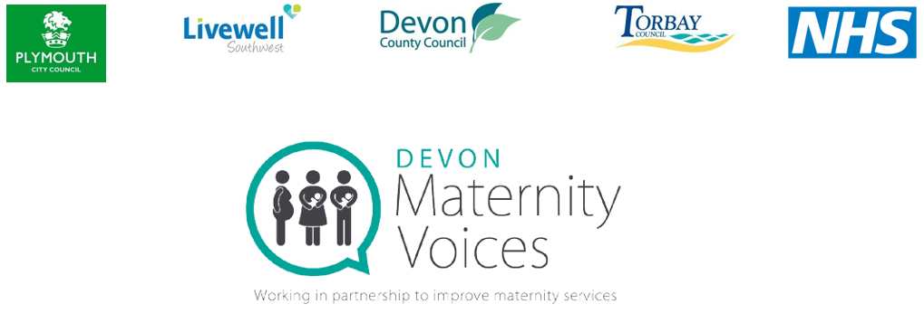Role description:
Vice Chair, Maternity Voices Partnership (MVP)

Job Purpose
Devon Local Maternity System (LMS) is working towards ensuring that parents and families are at the centre of safe and personalised maternity care. To support this, it is important to have an active and innovative Maternity Voices Partnership (MVP), which represents and supports those using maternity services throughout Devon.
Devon MVP is seeking a passionate and enthusiastic MVP Vice Chair for the North Devon area, who will join the MVP leadership team, linking with the North Devon Healthcare NHS Trust.
The Vice Chair will be elected for an initial term of two years.
You will ideally have recent lived experience of maternity care (preferably within the last five years). You need to be friendly and approachable, with the ability to engage with, and listen to, a diverse range of families, and to work in partnership with the Chair and local providers.
Role responsibilities
Service User Voice and Service development:
- Work with the co-Chairs to develop, review and report on an agreed programme of engagement and co-production for the MVP;
- Engage in coproduction with your local Trust e.g. for materials such as leaflets;
- Represent the views of service users and their families, and report back on MVP activity at some meetings as appropriate.
- Stand in for the co-Chair at the monthly LMS Board meeting on occasion, if required.
Engagement:
- Lead quarterly service user / parent representative meetings, for your local Trust area ensuring as far as possible that those meetings are inclusive, allowing everyone to contribute;
- Attend quarterly formal, Devon-wide MVP meetings to share the feedback gathered at your local Trust area service user meeting;
- Work with the MVP leadership team to design and implement innovative ways of engaging with service users and their families across Devon, proactively seeking and encouraging the voices of seldom heard communities;
Communication
- Assist the co-Chairs with regularly monitoring and updating the MVP email and social media accounts, and the MVP website;
- Use social media to engage with service users and to collect feedback e.g. via online surveys;
Leadership and Networking
- Recruit and support MVP volunteers locally
- Build and sustain relationships with the Devon MVP leadership team and with professionals in your local Trust area;
- Represent the voices of service users, and the activity and impact of the MVP, at MVP meetings, Vice Chairs may also have the opportunity to represent the MVP on occasion at regional or national events;
Partnership working
- In addition to working with providers of maternity services, the Vice Chairs may also have opportunities to work in partnership with:
  - Local neonatal services, and neonatal service user families;
  - Public Health Nursing services and other relevant Local Authority bodies;
  - Local Universities providing training for healthcare professionals (where applicable);
  - Third sector organisations who work with service users in their local Trust area, such as Healthwatch;
Knowledge
- Keep up-to-date with changes in maternity service provision, guidance and reports from relevant professional bodies and charitable organisations working to improve maternity services,

Skills
We see the Vice Chair as an expert who can demonstrate strategic and accountable leadership and decision-making. You should have the following skills:
- Friendly and approachable manner;
- Ability to support MVP volunteer members and service users;
- Ability to actively listen to service users and their families and accurately share their views;
- Ability to work effectively as part of the MVP leadership team;
- Ability to work collaboratively with service providers in your local Trust area;
- Confident with social media and Microsoft Office;
Nolan principles
In carrying out this role, the Vice Chairs will act in accordance with the Nolan Principles of conduct in public life . These are:
- Selflessness
- Integrity
- Objectivity
- Accountability
- Openness
- Honesty
- Leadership

Hours
Each Vice Chair will spend up to 8 hours (1 day) per month on MVP work. The Chair and Vice Chairs will be remunerated at the NHS England Patient and Public Voice rate of £150/day
https://www.england.nhs.uk/wp- content/uploads/2017/08/patient-andpublic-voice-partners-expenses-policy-oct-17.pdf).

Breakdown of activities
This will vary but may be:
- 1.5 hours leading/attending an MVP meeting (formal Devon-wide meetings, or local service user feedback sessions) or MVP event;
- 3 hours managing MVP email and social media accounts; and engaging with service users online;
- 1 hour contributing to the MVP leadership team meeting1 hours building and sustaining relationships to facilitate partnership working.
- 1.5 hours engaging with service users in a community setting, e.g. at community groups, or during “Walking the Patch” exercises.

