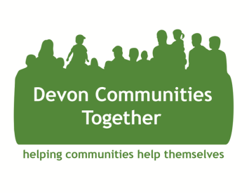

Local Giving Fund Grant Application
The Local Giving Fund is designed to fund play equipment for children and/or young people’s groups run in rural Devon. By completing and returning this simple application form before 23rd October 2024, you will be considered for a sum up to £300 to support a particular item or items for your community group. By accepting this grant, you agree to buy said item(s) and share brief feedback on the impact of the monies spent.
Name of Community Group:

Devon district:

How often does your group meet:

Numbers attending your community group:

Item(s) requested:

Total cost of item(s):

How would this/these items help your young people’s group:

Full name & committee position:

Signature:

Date:

Contact number & email:

Please return your completed form to info@devoncommunities.org.uk no later than 22nd October 2024.

