Torbay, Devon and Plymouth Assembly Representative Report
Sarah-Lou Glover
Representative:

SIG SLCN & Neurdiversity
Group or Board:

Date of meeting:
10th June & 8th July 2024

Overall Purpose of Assembly VCSE Representation:
The aim of representation on behalf of the VCSE Assembly is to contribute a wider range of views, improve access to information and increase influence, The VCS representative is not intended to be the sole representative of the sector in any discussion with statutory partners nor, when attending a meeting in a representative capacity are they speaking on behalf of their own organisation. They are funded and supported to feed back information afterwards. Representatives are expected to use existing networks and structures to gather and feed back views but can also be contacted directly by any VCS organisation with an interest.

Meeting Details

Main Agenda Items:

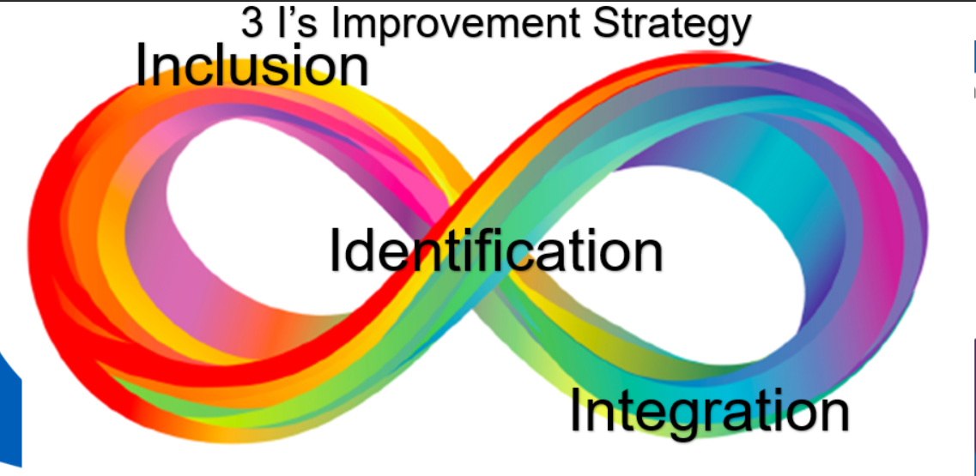
Parent neurodiversity overview shared by PCFD.
Worked through the development plan for the coming year including the new strategy developed by parent carer forums and how that will influence the work moving forward.
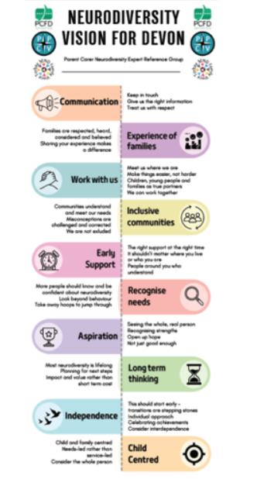

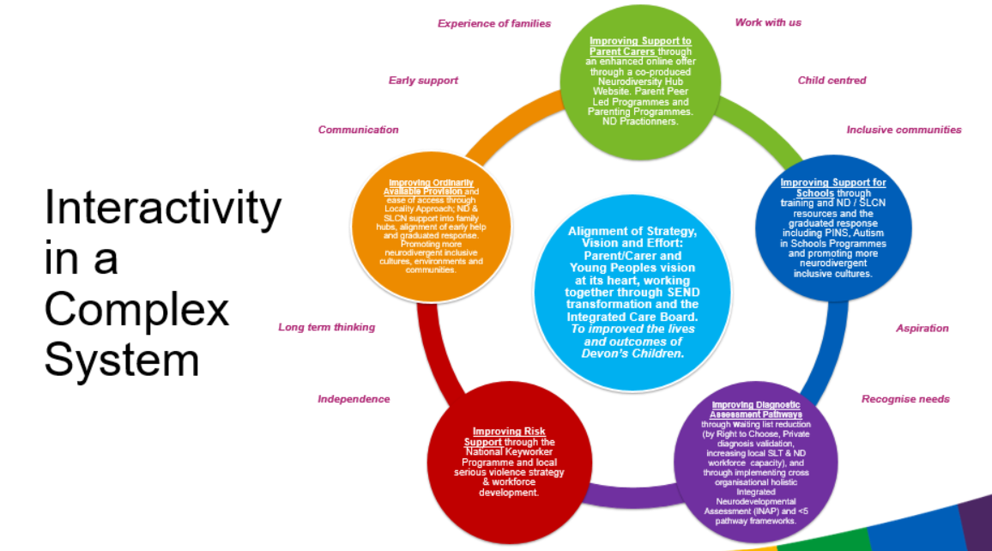

How did you contribute to the meeting:
Please indicate how you promoted the VCSE’s value and contribution, shared VCSE’s experiences, challenged and influencing thinking and contributed to specific developments or agenda items.

Shared updates from Family Minds new work
Shared information feedback on the above and how we might use this moving forward
Suggested that we need to let the wider system know about the work happening in this space – shared the One Devon slide that we use in the Eastern Devon CYP to share to the system and to families

Feedback to the VCSE Assembly

For Information: Looking at various aspects of SLCN & Neurodiversity, including waiting well (Anna Adlam) and embedding updates on the Family Hubs – conversation is continuing. Due to attend the waiting well conference.

For Action: No action at this time

