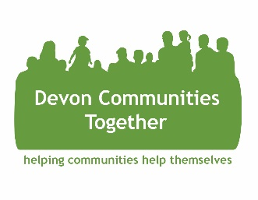

E-Workbook

Starting Your Rural Enterprise -

A practical approach

Dr. Louise MacAllister
Devon Communities Together

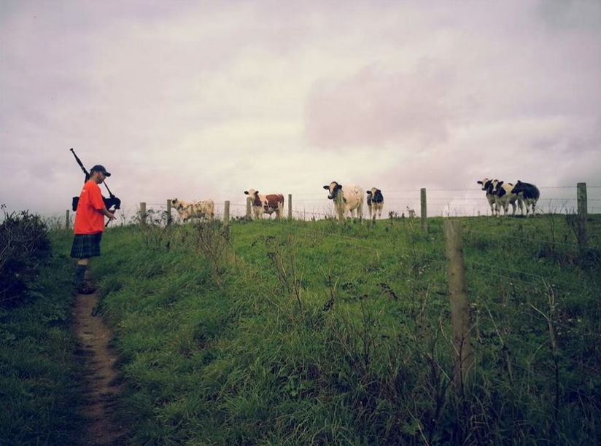

This workbook will take you through a practical series of exercises that will help you clarify your business purpose and think about the market environment, this will give you the building blocks of a business plan.
The following pages are designed to prompt you to think about the practical considerations needed in order to go on to create an action plan.
- Write down in no more than 50 words the purpose of your planned enterprise (Vision, Mission, Aims & Objectives)
……………………………………………………………………………………………………………………………………………………………………………………………………………………………………………………………………………………………………………………………………………………………………………………………………………………………………………………………………………………………………………………………………………………………………………………………………………………………………………………………………………………………………………………………………………………………………………………………………………………………………………………………………………………………………………………...
……………………………………………………………………………………………………………………………………………………………………………………………………………………………………………………………………………………………………...
- Where will your earnings come from? Who pays for the service or products?
………………………………………………………………………………………………………………………………………………………………………………………………………………………………………………………………………………………………………
- Can you cover all your costs? Will you make a profit?
………………………………………………………………………………………………………………………………………………………………………………………………………………………………………………………………………………………………………
- How will you measure financial success?
……………………………………………………………………………………………………………………………………………………………………………………………………………………………………………………………………………………………………
- What will happen to that profit – who will ‘own’ the business?
………………………………………………………………………………………………………………………………………………………………………………………………………………………………………………………………………………………………………
Understanding the market and context
- Describe in no more than 25 words the products or services you are selling? (e.g. hiring space, products and services etc)
……………………………………………………………………………………………………………………………………………………………………………………………………………………………………………………………………………………………………………………………………………………………………………………………………………………………………………………………………………………………………………
- Have you researched the market? Do you know there is a need for your services/products? If yes, who is your market and what do you know about them?
……………………………………………………………………………………………………………………………………………………………………………………………………………………………………………………………………………………………………………………………………………………………………………………………………………………………………………………………………………………………………………………………………………………………………………………………………………………………………………………………………………………………………………………………………………………………………………………………………………………

- Who are your competitors? Make a list of your competitors, where they operate, and what specific angle and benefits do they offer the market:
…………………………………………………………………………………………………………………………………………………………………………………………………………………………………………………………………………………………………………………………………………………………………………………………………………………………………………………………………………………………………………………………………………………………………………………………………………………………………………………………………………………………………………………………………………………………………………………………………………………………………………………………………………………………………………………………………………………………………………………………………………………………………………………………………………………………………………………………………………………………………………………………………………………………………………………………………………………………………………………………………………………………………………………………………………………………………………………………………………………………………………………………………………………………………………………………………………………………………………
- Can you see any clear gaps in what your competitors offer?
…………………………………………………………………………………………………………………………………………………………………………………………………………………………………………………………………………………………………………………………………………………………………………………………………………
- Now think about what your competitors DON’T offer. Why will people buy from you rather than someone else? Can you identify your Unique Selling Point (USP)?
…………………………………………………………………………………………………………………………………………………………………………………………………………………………………………………………………………………………………………………………………………………………………………………………………………

- Who are your stakeholders and collaborators? Make a list.
……………………………………………………………………………………………………………………………………………………………………………………………………………………………………………………………………………………………………………………………………………………………………………………………………………………………………………………………………………………………………………………………………………………………………………………………………………………………………………………………………………………………………………………………………………………………………………………………………………………………………………………………………………………………………………………………………………………………………………………………………………………………………………………………………………………………………………………………

Community groups and individuals
Stakeholders
Employees
Suppliers
Topical expertise
Governance inc legal & regulatory
Investors
Customers
PESTLE (Political, Economic, Social, Technological, Legislative, Environmental) analysis.
A PESTLE analysis helps you to think about all of the contexts in which you will operate. You are unlikely to be able to change these contexts but they are likely to influence your business in various ways. Think about how these contexts may lead to new opportunities for your business or possible constraints.
List external factors that influence your business under the following headings. Think about both current contexts and likely future trends – you may need to carry out some background and horizon scanning research to best understand these contexts:
Political
………………………………………………………………………………………………………………………………………………………………………………………………………………………………………………………………………………………………………………………………………………………………………………………………………………………………………………………………………………………………………………………………………………………………………………………………………………
Economic
………………………………………………………………………………………………………………………………………………………………………………………………………………………………………………………………………………………………………………………………………………………………………………………………………………………………………………………………………………………………………………………………………………………………………………………………………………
Social
………………………………………………………………………………………………………………………………………………………………………………………………………………………………………………………………………………………………………………………………………………………………………………………………………………………………………………………………………………………………………………………………………………………………………………………………………………
PTO…
Technological
………………………………………………………………………………………………………………………………………………………………………………………………………………………………………………………………………………………………………………………………………………………………………………………………………………………………………………………………………………………………………………………………………………………………………………………………………………
Legislative / Legal
………………………………………………………………………………………………………………………………………………………………………………………………………………………………………………………………………………………………………………………………………………………………………………………………………………………………………………………………………………………………………………………………………………………………………………………………………………
Environmental
………………………………………………………………………………………………………………………………………………………………………………………………………………………………………………………………………………………………………………………………………………………………………………………………………………………………………………………………………………………………………………………………………………………………………………………………………………
SWOT ( Strengths, Weaknesses, Opportunities, and Threats) analysis
Using the insights from the PESTLE analysis, a SWOT analysis enables you to think about your business’s strengths and weaknesses, as well as the opportunities and threats it faces in the marketplace.
Fill out the SWOT template on the next page, using bullet points, with your:
Strengths – positive factors internal to your business that you have control over. Eg, resources, skills, and knowledge.
Weaknesses – internal factors that in some way leave you at a disadvantage, you may like to ask yourself what your company struggles with, why might customers select to use your competitors rather than your company, or is there anything specific that stops your company from achieving?
Opportunities – what external factors will contribute to your growing success? Think about opportunities within the contexts you have identified in your PESTLE analysis and any trends.
Threats - what external factors may negatively affect your business? Think about threats within the contexts you have identified in your PESTLE analysis and any trends.

Strengths | Weaknesses
Opportunities | Threats

Once you have carried out a SWOT analysis you can start thinking about actions to maximise your strengths and minimise weaknesses and threats, by bringing together the quadrants of the SWOT analysis to answer the following questions:
How can you use your company’s strengths to maximise the opportunities you have identified, what actions can you take?
………………………………………………………………………………………………………………………………………………………………………………………………………………………………………………………………………………………………………………………………………………………………………………………………………………………………………………………………………………………………………………………………………………………………………………………………………………
How can you use your company’s strengths to minimise the threats you have identified, what actions can you take?
………………………………………………………………………………………………………………………………………………………………………………………………………………………………………………………………………………………………………………………………………………………………………………………………………………………………………………………………………………………………………………………………………………………………………………………………………………
How can you minimise your weaknesses using the opportunities identified, what actions can you take?
………………………………………………………………………………………………………………………………………………………………………………………………………………………………………………………………………………………………………………………………………………………………………………………………………………………………………………………………………………………………………………………………………………………………………………………………………………

How can you minimise your company’s weaknesses by avoiding the threats you have identified, what actions can you take?
………………………………………………………………………………………………………………………………………………………………………………………………………………………………………………………………………………………………………………………………………………………………………………………………………………………………………………………………………………………………………………………………………………………………………………………………………………
Having worked through the exercises in this workbook you are now in a strong position to approach your business plan. Below is some advice on structuring the business plan from the ERDF funded Business Link:

Writing your Business Plan

Front Cover

Create a striking front cover that reflects the style of your business. Include your name, address, telephone and fax number, e-mail address and website if you have one. You could include your logo or an eye-catching picture of one of your products or services. Clearly indicate the period covered in the business plan.

Contents
It is important to have your business plan clearly laid out in sections and a contents page with headings and page numbers which will guide the reader quickly to a particular page.
Executive Summary
Although at the front of your business plan, this is usually the last section to be written and is quite literally a summary of your business plan, maximum of two pages. Remember, even if the reader has not read the full business plan the executive summary should be able to convey who you are and what you are trying to do.

Background Information

Say a bit about the history of your business and how your social enterprise has developed. Who is involved, what you do, where you are based, the area you cover; how you have developed; significant milestones; relevant partners etc.

Services and Products

Describe your products or services. Brochures, leaflets, posters, photographs, diagrams, plans, maps can be included either here or in the appendices and referred to in the text.

Marketing Plan

This is a crucial part of the business plan and you will need to answer some of the following questions. Who are your customers? How do you know your customers want your products or services? How will you target your customers? Who are your competitors? Will your products or services complement any existing products/services? How have you arrived at your pricing structure? Where are your products/services placed in the market? What promotional and advertising activities will you undertake? Will you be able to move into a different or additional market? Gathering this information together is your market research. This will provide the evidence that your business idea is viable and that you actually have customers who want to buy your products and services.
Make reference to any demographic data, census information, surveys, questionnaires, relevant reports, local/central government policies etc.

You could include the results of a SWOT analysis (Strengths, Weaknesses, Opportunities, Threats affecting your business). How will you minimise the weaknesses and threats and maximise the strengths and opportunities? Also include a PESTLE analysis (Political, Economic, Social, Technological, Legal and Environmental factors affecting your business). How will these issues impact on your products and services?

Operational Plan

Describe the details of exactly how you will deliver your services. Put in as much detail as possible about how your product or service is constructed and how/where/by what means the customer actually receives the product or service. Are there peak and low operational periods? Look ahead and describe how the business will develop by illustrating your short, medium and long-term goals.

Include what resources are needed; staff including any training that will have to be done; the premises and facilities required; all the necessary equipment.

List the policies and procedures that will support the operation, you could include copies of equal opportunities, recruitment and selection; health and safety; customer care and others in the appendices.

Can you summarise the critical factors for success in your business.

Management Plan

Start by describing the company structure of the social enterprise, followed by the internal management structure. Describe the staff roles and their responsibilities, and address any skill gaps by including a training plan. Outline any procedures for line management, staff accountability and supervision. Include your policies and procedures for volunteers if these are relevant to your business. The use of diagrams can be very helpful in this section.

Financial Plan

This is the vital part of your business plan and often the section which is looked at by many people before anything else! Showing that your social enterprise is sustainable and will not collapse after any initial funding has disappeared is important. By completing the other sections of the business plan you should have already arrived at most of your costings, these should be illustrated through budgets and cash flow forecast for at least a 3 year period.

Include a page of detailed notes to the budget explaining sources of income and expenditure and how you arrived at your calculations, this can save a few questions later.

It is important to develop financial policies and procedures that include details of the financial systems your business will use and the controls on those systems. Who will sign cheques? What information will be used to make financial decisions in the business?

Give details of your accountant and auditor if you can.

Appendices
You can include here any documents that are too detailed or bulky to go in the main body of the text. These could include some of the following:

- Brochures, Leaflets, Photographs, Diagrams, Maps

- Market research information, Questionnaires, Surveys
- References, Professional advisers
- Job descriptions, if relevant
Other supporting material relevant to your social enterprise

