Election Nomination form for Devon Maternity Voices Partnership (MVP) Chair
Summer 2019
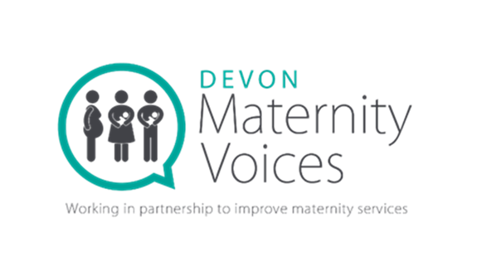

- Name

- Postal Address

- Email

- Telephone number

- Date

- What skills, knowledge and experience do you have for the role of MVP Chair (no more than 500 words).

- What you would hope to achieve as MVP chair (no more than 500 words).
- Have you in the last five years been convicted in or outside the United Kingdom of any offence?

YES

NO

- Have you been subject to a bankruptcy restrictions order or an interim bankruptcy restrictions order under Schedule 4A to the Insolvency Act 1986(33), sections 56A to 56K of the Bankruptcy (Scotland) Act 1985(34) or Schedule 2A to the Insolvency (Northern Ireland) Order 1989(35)?

YES
NO

- Have you in the last five years been dismissed from paid employment other than because of redundancy?

YES
NO

- Have you been subject to an investigation or proceedings, by any regulatory body, in connection with your fitness to practise, or any alleged fraud?

YES
NO

- Have you been disqualified from being a company director or removed from the office of charity trustee, or removed or suspended from the control or management of a charity, on the grounds of misconduct or mismanagement?

YES

NO

