Devon Community Resilience Fund
Pre plan (Phase 1) Up to £250
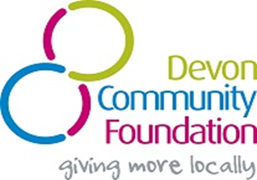

Support for Communities to Develop a Community Emergency Plan

Pre plan Community Resilience Application Form

About the Group

Name

Address

Post Code

District / Local Authority
Are you part of the Devon Community Resilience Forum (see Guidelines)? |  | YES / NO
If not please confirm that you have registered by sending your details to: info@devoncommunities.org.uk re: DCF Grant |  | Date emailed:

About you (Main Contact)

First name
Surname
Your role

Telephone

Mobile

Email

Address

Post Code
What you are applying for?

Please confirm that you are working to develop a Community Emergency Plan |  | YES / NO
If you are not the Town or Parish Council please provide the name of a Town or Parish Councillor who will support your application. |  | Councillor:
What will this funding be used for?

Why is this needed? How will it help you develop your Emergency Plan?

What is the total cost?

How much are you applying for?
When do you expect to finish writing your Emergency Plan?

Please email this to grants@devoncf.com

Please check you have read the guidelines

